Oral drug delivery due to excellent accessibility and reasonable patient compliance offers attractive route for drug administration (1). However, major drawback of administering drug orally is that many therapeutic agents are subjected to extensive pre systemic elimination by gastrointestinal degradation or first pass hepatic metabolism (2, 3), results in low systemic bioavailability and shorter duration of therapeutic activity or formation of inactive or toxic metabolites (4, 5). Moreover, the quick passage of dosage forms through the absorptive segment of GIT often leads to unutilized drug, particularly in case of extended delivery of narrow absorption window drugs (6). Controlled release drug delivery technology are opted for minimizing the frequency of administration by keeping the drug in therapeutic window for longer period of time, safe guarding patient compliance and reduces drug wastage through improving the efficacy of drugs (7, 8). However, controlled release technology is inadequate and incapable of increasing gastric resident time of drugs (9). In order to improve the gastric residence time for drugs exhibiting an absorption window for continuously releasing the drug for a pro- longed period before it reaches the absorption site, various approaches including floating systems, bio adhesive systems, swelling and expanding systems and high density systems have been success- fully employed (10, 11). The concept of muco adhesion was introduced into controlled drug delivery in the early 1980s. Bio adhesion is defined as the state in which two materials, at least one of them being biological in nature, are held together for an extend- ed period of time by interfacial forces and when the biological material involved is mucosa, then the concept is termed muco adhesion (12). Response surface methodology (RSM) is a widely practiced approach in the development and optimization of drug delivery devices. Based on the principle of design of experiments, the methodology encompass- es the use of various types of experimental designs, generation of polynomial equations, and mapping of the response over the experimental domain to deter- mine the optimum formulation(s). The technique requires minimum experimentation and time, thus proving to be far more effective and cost-effective than the conventional methods of formulating dosage forms (13, 14).

Domperidone is synthetic benzimidazole com- pound that act as dopamine D2 receptor antagonist drug widely used in the treatment of motion-sick- ness. It is rapidly absorbed from the stomach and the upper part of the GIT by active transport, after oral administration, and few side effects have been reported. It is a weak base with good solubility in acidic pH but in alkaline pH solubility is significantly reduced. Oral controlled release dosage forms containing drug, which is a weak base, are exposed to environments of increasing pH and poorly soluble free base may get precipitated within the formulation in the intestinal fluid. Precipitated drug is no longer capable of being released from the formulation. It is absorbed orally, but bioavailability is only 15% due to first pass metabolism. It is eliminated during 7 h after single oral administration; its con- centration peak at 30 min following oral administration also favors development of a sustained release formulation (15).

Gum Ghatti (GG) is the amorphous translucent exudate of the Anogeissus Latifolia tree of the Combretaceae family. The tree occurs throughout the greater part of India; more commonly in the dry deciduous forests. The gum, locally called Dhavda, when first exuded is in a soft plastic form (16).

In present study, SRMM tablets were prepared using various proportions of GG and HPMC K 15M. The formulated tablets were characterized through tablet parametric tests, mucoadhesive strength and *in vitro* drug release studies and optimized using RSM and design of experiment (DoE) for selecting optimum formulations with desired responses. Polynomial equations thus generated were used for mapping the responses over the experimental domains for determining the optimum formulation.

## MATERIALS AND METHODS

**Materials**

Domperidone and HPMC K 15M were received as gift samples from Helios Pharmaceuticals, Baddi, India. Vivapur-102 was kindly gifted by S. Zhaveri, Mumbai, India. Gum ghatti was procured from Loba Chemie, Mumbai, India. Talc and magnesium stearate were purchased from S. D. Fine Chemicals Ltd. Mumbai, India. All other chemicals and reagents were of analytical grade and were used as such.

## Characterization of gum ghatti

GG was characterized for swelling index, viscosity, pH and for microbial load. Microbial load was determined as outlined in Indian Pharmacopoeia 2007 for total aerobic count using plate count method. Pre-treated sample was inoculated on nutrient agar plates and were incubated for 96 and 120 h at 34 ± 0.5 and 22 ± 0.5OC for bacteria and fungi, respectively. Then, the number of colony forming units was calculated for bacteria and fungi.

## Preparation of tablets

SRMM tablets containing domperidone were prepared by direct compression technology using variable concentrations of GG and HPMC K 15M according to Table 1. Before use, drug and polymers (GG, HPMC K 15M and Vivapur 102) were screened through 80 mesh sieve (size: 180 m), while talc and magnesium stearate were screened through # 120 mesh sieve (size: 125 m). All the materials were accurately weighed and mixed intimately in a polyethylene bag for 2 min. The directly compressible mixtures were compressed into tablet using 8.5 mm standard concave punch with single stroke multi punch tablet punching machine (AK Industries, India) and keeping average weight of 250 mg. All domperidone loaded mucoadhesive matrix tablets were stored in air tight container at room temperature for further study.

|  |  |
| --- | --- |
| Ingredients | Quantity (mg) |
| Domperidone | 30 |
| Gum ghatti | 20ñ60 |
| HPMC K 15 M | 30ñ50 |
| Talc | 2 |
| Magnesium sulfate | 2 |
| Vivapur 102 qs to | 200 mg |

|  |  |  |  |  |  |
| --- | --- | --- | --- | --- | --- |
| Trail  No. | | Coded factor levels | | | |
| X1 | | X2 | |
| Z1 | | ñ1 | | ñ1 | |
| Z2 | | 0 | | ñ1 | |
| Z3 | | 1 | | ñ1 | |
| Z4 | | ñ1 | | 0 | |
| Z5 | | 0 | | 0 | |
| Z6 | | 1 | | 0 | |
| Z7 | | ñ1 | | 1 | |
| Z8 | | 0 | | 1 | |
| Z9 | | 1 | | 1 | |
| Translation of coded levels in actual units | | | | | |
| Coded level | -1 | | 0 | | 1 |
| Gum ghatti (mg) | 20 | | 40 | | 60 |
| HPMC K 15M (mg) | 30 | | 40 | | 50 |

## Experimental design

Based on evaluation of prototype formulation, two polymers were found to be having predominant effect on bio adhesive strength and drug release. A central composite design with  = 1 was employed to study the effect of two independent variables (X1

= % GG and X2 = % HPMC K 15M) in three different concentrations on the dependent variables like mucoadhesive strength, tensile strength, n, t50, rel10 h and rel18 h. Formulations Z1ñZ9 were prepared by varying the levels of the independent variables as required by the experimental design and factors levels were suitably coded in Table 2.

## Evaluation of tablets

*Drug assay and physical evaluation*

Twenty tablets were powdered individually and a quantity equivalent to 100 mg of domperidone was accurately weighed and extracted with a suit- able volume of 0.1 M HCl. Each extract was filtered through Whatman filter paper No. 41 (Whatman Paper Limited, UK) and analyzed spectrophotometrically (Systronics 2202, India) at 284 nm after sufficient dilution. The formulated tablets were also evaluated for hardness using a Monsanto hardness tester (Pharma Chem Machineries, Mumbai, India), friability using Roche friabilator (Digital friability test apparatus, Model 102 EI, India), weight varia tion using analytical balance (Citizen CY 200), and thickness using digital vernier callipers (Mitutoyo, absolute digimax caliper, CD 6î CSX, Japan).

*Tensile strength*

The tablet tensile strength is the force required to break a tablet by compressing it in the radial direction and was measured using a Monsanto hard- ness tester. Tensile strength for crushing (T) is calculated using equation:

T = 2F /  d t

where F is the crushing load, and d and t denote the diameter and thickness of the tablet, respectively.

*Ex vivo mucoadhesive strength*

Porcine gastric mucosa were utilized as the model membrane for *ex vivo* bio adhesive strength determination of various formulations. The mucosal membrane was excised by removing the underlying connective tissue and was placed on the base of Texture Profile Analyzer (TAXT plus, Stable Micro Systems, UK). A tablet was attached to the stainless steel probe fixed to the mobile arm of the texture analyzer. The area of contact of mucosa was moistened with 50 L of SGF. The mobile arm was lowered at a rate of 0.5 mm/s until a contact with the membrane was made. A contact force of 1 N was maintained for 60 s, after which the probe was with- drawn from the membrane at a 0.5 mm/s to the distance of 15 mm. The peak detachment force was recorded as a measure of bio adhesion (17).

***In vitro* drug release study**

The *in vitro* drug release studies of the SRMM tablets were conducted in eight stage USP type II dissolution apparatus (Lab India, DS 8000) equilibrated at temperature 37 ± 0.5OC and 50 rpm speed. The dissolution studies were carried out in triplicate for 24 h in 900 mL of 0.1 M HCl (pH 1.2) as a buffer. The dissolution samples were collected at every 1 h interval for 24 h and replaced with an equal volume of buffer to maintain the volume constant. The sample solution was diluted sufficiently and analyzed at 284 nm by a UV spectrophotometer (Systronics 2202, India). The amount of drug present in the sample was calculated with the help of appropriate calibration curves constructed from reference standard of the respective drug. Drug dis- solved at specified period was plotted as a percent release versus time (h) curve, depicted in Figure 1.

## Data analysis

To analyze the *in vitro* release data, various kinetic models were used to describe the release kinetics. The zero order rate (Eq. 1) describes the systems where the drug release rate is independent of its concentration (Fig. 1). The first order rate (Eq. 2) describes the release from system where release rate is concentration dependent (Fig. 2). Higuchi equation (18) (Eq. 3) described the release of drugs from insoluble matrix as a square root of time dependent process based on fickian diffusion (Fig. 3). The Hixson-Crowell cube root law (19) (Eq. 4) describes the release from systems where there is a change in surface area and diameter of particles or tablets (Fig. 4).

C = kot (1)

where, k0 is zero-order rate constant expressed in units of concentration/time and t is the time.

Log C = Log C0 ñ k1t/ 2.303 (2) where C0 is the initial concentration of drug and k1 is first order constant.

Q = kHt1/ 2 (3)

where kH is the rate constant for Higuchi equation.

Q 1/3 ñ Q 1/3 = k t (4) where Qt is the amount of drug released in time t, Q0 is the initial amount of the drug in tablet and kHC is the rate constant for Hixson-Crowell rate equation.

0 t HC

The following plots were made: cumulative % drug release vs. time (zero order kinetic model); log cumulative of % drug remaining vs. time (first order

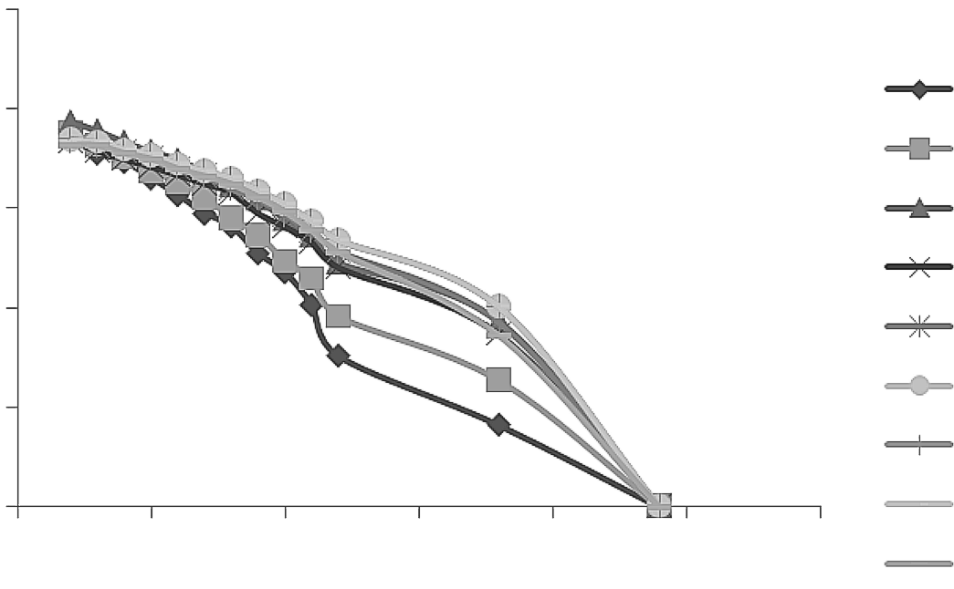

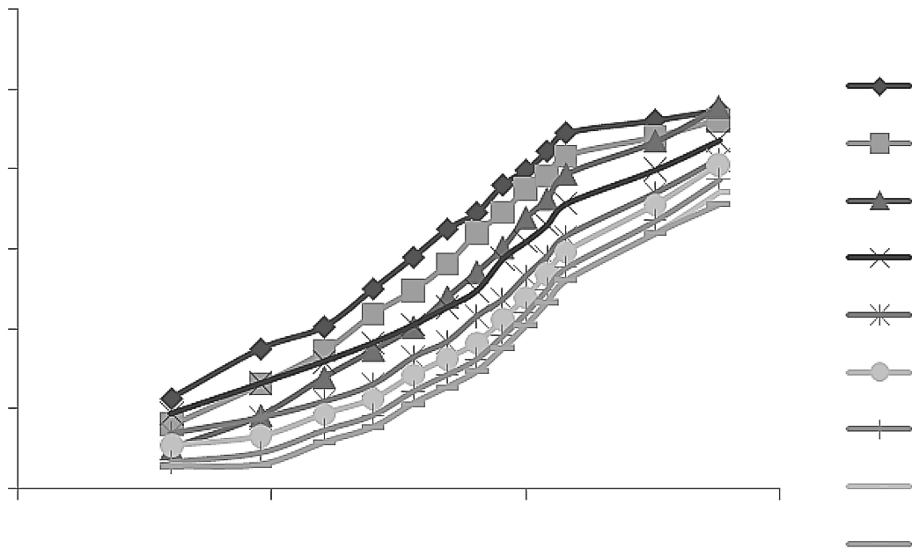

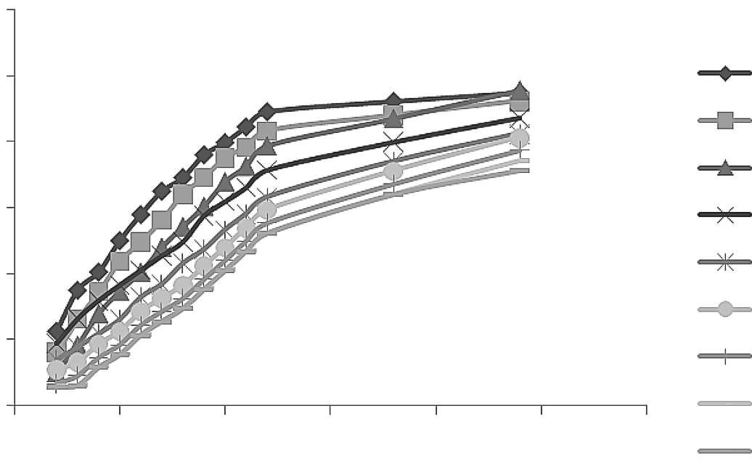

kinetic model); cumulative % drug release vs. square root of time (Higuchi model); (Korsmeyer- Peppas model) and cube root of drug % remaining in matrix vs. time (Hixson-Crowell cube root law).

## Mechanism of drug release

Korsmeyer et al. (20, 21) derived a simple relationship between log cumulative % drug releases vs. log time, which described drug release from a polymeric system (Eq. 5). To find out the mechanism of drug release, first 60% drug release data were fitted in KorsmeyerñPeppas model (Fig. 5):

Mt / M8 = kKP t (5)

where Mt / M8 is a fraction of drug released at time t, kKP is the rate constant and n is the release expo- nent. The n value is used to characterize different release mechanisms as given in table for cylindrical shaped matrices. The value of n = 0.45 indicates a classical fickian diffusion-controlled (case I) drug release, n = 0.89 indicates a case II relaxational release transport; non-fickian, zero-order release and n > 0.89 indicates super case II (increased plas- ticization at the relaxing boundary) type of release. Values of n between 0.45 and 0.89 can be regarded as an indicator of both phenomena (drug diffusion in the hydrated matrix and the polymer relaxation) commonly called anomalous transport.

## Optimization data analysis and validation of optimized model

The traditional approach to developing a formulation is to change one variable at a time. By this method it is difficult to develop an optimized formulation, as the method reveals nothing about the interactions among the variables. Various response surface methodology (RSM) computations for the current optimization study were performed employing the design expert software (Version 7.0.0, Stat- Ease). Hence, a CCD with 2 factors, 3 levels, and 9 runs was selected for the optimization study. In this design, 2 formulation independent factors are evaluated, each at 3 levels (low, medium and high), and experimental trials are performed at all 9 possible combinations. GG (X1) and HPMC K 15M (X2), were selected as independent variables. Mucoadhesive strength, tensile strength, n, t50, rel10 h and rel18 h were selected as dependent variables. After application of CCD and with the aid of produced polynomial terms, the amount of two formulation variables was optimized. The optimized amount of the GG and HPMC K 15M were incorp rated in the tablet which was used as the check point of the regression analysis model. The polynomial equation 6 generated by this experimental design (using Design Expert 7.0.0 software,

1

2

Y = 0 + 1X1 + 2X2 + 3X1 X2 + 4X 2 + 5X 2 (6)

where, 0 is the intercept representing the arithmetic average of all quantitative outcomes of 13 runs; 1 to

5 are the coefficients computed from the observed experimental values of Y; and X1 and X2 are the coded levels of the independent variable(s). The terms X1X2 and X 2 (i = 1 to 2) represent the interaction and quadratic terms, respectively. Statistical validity of the polynomials was established on the basis of ANOVA provision in the design expert soft- ware.

i

***Ex vivo* mucoadhesion time**

The *ex vivo* muco adhesion time was per- formed (n = 3) after application of the tablet on freshly cut rat stomach mucosa. The fresh rat stomach mucosa was tied on the glass slide with the help of double sided tape and the optimized tablet was wetted with 1 drop of 0.1 M HCl (pH 1.2) and pasted to the rat stomach mucosa by applying a light force with a fingertip for 30 s. The glass slide was placed at the bottom of vessel pad- dle type USP Type-II (Lab India, DS 8000) appa- ratus. The test was performed with 900 mL of the

0.1 M HCl at 37 ± 1OC. After 2 min, a 50 rpm stir- ring rate was applied to simulate the stomach environment, and tablet adhesion was monitored for 24

h. The time for the tablet to detach from the rat stomach mucosa was recorded as the mucoadhesion time (22). The experimental protocol was approved by the institutional animal ethics committee and the animals were cared as per the guidelines of the committee for the purpose of control and supervision of experiments on animals (CPCSEA), Ministry of Environment and Forests, Government of India (Reg No. 107/1999/CPC- SEA).

## Stability studies

The success of an effective formulation can be evaluated only through stability studies. The purpose of stability testing was to obtain a stable product, which assures its safety and efficacy up to the end of shelf life at defined storage conditions and peak profile. Accelerated stability testing was carried out according to ICH guidelines (40OC / 75% RH). One hundred tablets of each batch were securely packed in HDPE bottles and kept in a stability chamber. Tablets were evaluated at 0 day and after 3 and 6 months for tensile strength, mucoadhesive strength and drug assay.

## RESULTS AND DISCUSSION

**Characterization of GG**

Swelling index of 1% w/v solution of GG was found to be 21, which indicated good swelling tendency of the natural gum. Viscosity of 1% w/v solution of GG using spindle number 61 of Brookfield viscometer at 37 ± 1OC was found to be 50, 25.5,

13.2 and 5.5 at 6, 12, 30 and 60 rpm, respectively. pH of 1% w/v solution at 37 ± 1OC was found to be 6.87.

As natural materials are prone to possess microbial contamination so it became necessary to perform microbial load studies. Total aerobic count using plate count method was determined as given in Indian Pharmacopoeia 2007. The number of colony forming units were found to be 55 CFU/g and 9 CFU/g for bacteria and fungi, respectively (Fig. 6), which were well within limits as per Indian Pharmacopoeia 2007 for total aerobic count.

## Drug assay and physical evaluation

The assessment results for physical parameters and drug assay for designed SRMM tablet formulations are shown in Table 3. The assayed content of drug was found between 99.19 ± 0.64 and 99.97 ± 0.71% for different formulated batches, showing

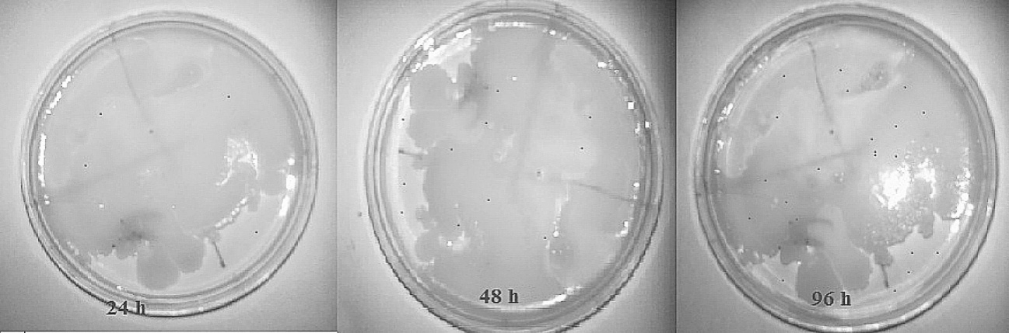

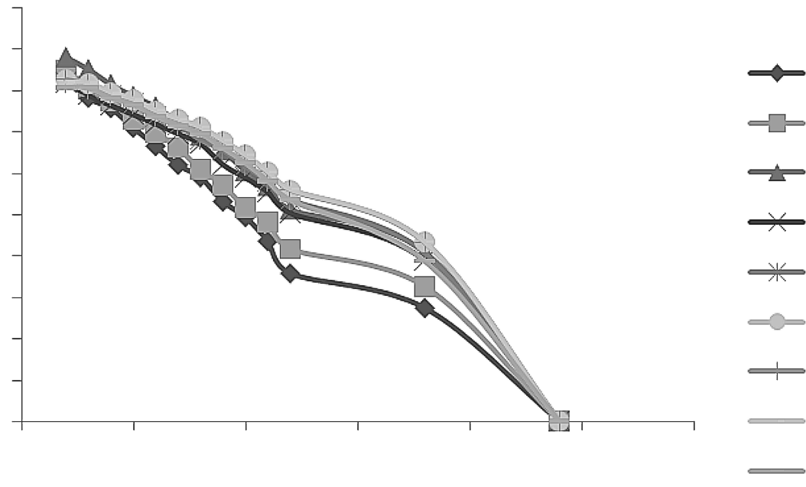

Figure 5. Hixson-Crowell cube root plots of domperidone from SRMM tablets

that even changing experimental parameters i.e., changing the polymer concentrations, did not effect drug content. The hardness of all prepared batches was found to be ranging between 3.5 ± 0.50 to 8.5 ±

0.50 kg/cm2 (Z1 to Z9). This extensive hardness without addition of any binding agent in formulation indicates the binding potential of GG. The maxi- mum diameters and thickness of prepared tablets was found to be 8.5 ± 0.3 mm and 4.0 ± 0.2 mm. The friability of formulated tablets was found to be decreased from 0.16 ± 0.02 to 0.01 ± 0.01% (Z1 to Z9) and tensile strength raised from 0.665 ± 0.1 to

1.591 ± 0.1 MN/cm2 (Z1 to Z9) with the increase in polymer concentrations. This decline in friability and raise in tensile strength with proportional increase in polymer concentration pointed towards the binding property of GG.

***In vitro* drug release profile**

The release of domperidone from the prepared SRMM tablet formulations was analyzed by plotting the cumulative percent drug released vs. time as shown in Figure 1. The release profile found to be declined from 94.75 to 71.29% (Z1 to Z9) indicating the release retardant belonging of GG and HPMC K 15M with the increase in concentration of both polymers. These release patterns indicates the matrix forming belonging of HPMC K 15M and natural gum (GG), which might be responsible for con- trolling the release of drug through the formation of sound matrix .This may be due to the increased viscosity of the gel layer around the tablet with an increase in the polymers concentration, thus limiting the release of active ingredient. At high levels of both the polymers, a significant fraction of the drug (~28%) remained unreleased until 24 h.

## Release kinetics and mechanism of release

Several kinetic models describe drug release from immediate and modified release dosage forms. The correlation coefficient (r) value was used as

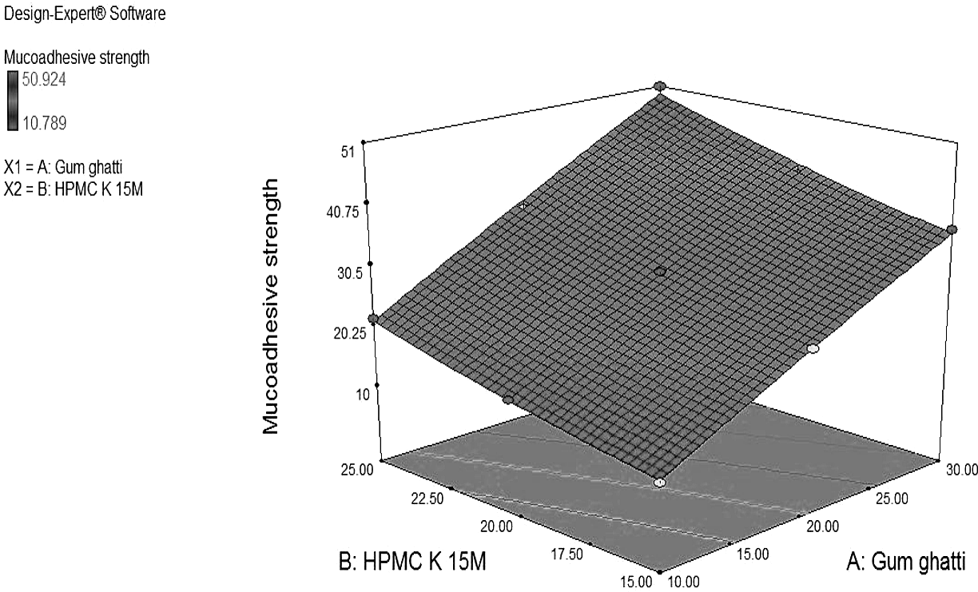

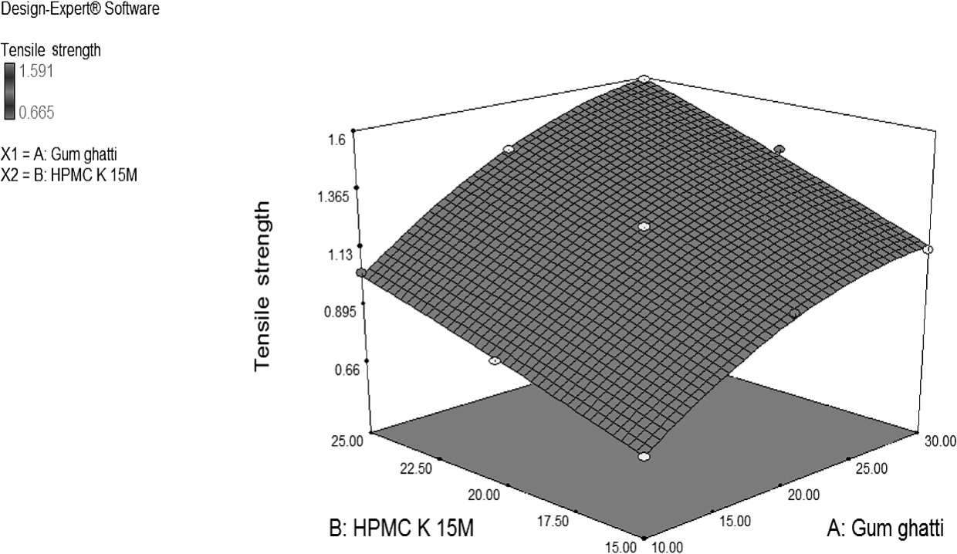

criteria to choose the best model to describe drug release from the mucoadhesive controlled release tablets. The R-values in various models is given in Table 4. In most of the formulated tablets, the r values were higher in first order model than in zero order model indicating that the drug release from most of the tablets was dependent on remaining drug concentration. The R-values (r = 0.982) obtained for fitting the drug release data to the Hixson Crowell equation, indicated that the drug release mechanism from these tablets was erosion and diffusion controlled. There was a decrease in the surface area of the tablet with time as dissolution proceeded. The values of n in Peppas model also indicated that the release exponent shifts from non-Fiskian to super case II with the increasing

polymer concentration. The release exponent rise from 0.834 ± 0.12 to 1.171 ± 0.05 and 1.211 ± 0.09

to 1.273 ± 0.11 at low and high level of HPMC K 15M, respectively, as the concentration of GG is increased and n amplified from 0.834 ± 0.12 to

1.211 ± 0.09 and from 1.171 ± 0.05 to 1.273 ± 0.11

at low and high levels of GG, respectively, as the concentration of HPMC K 15M increased. This indicates that the release mechanism shifted from combination of erosion as well as diffusion to ero- sion only along with polymer disentanglement with plasticization of relaxing boundaries.

## Mathematical modelling

Mathematical relationships generated using design expert software (Design Expert 7.0.0 soft-

## CONCLUSION

In our study, we developed sustained release domperidone mucoadhesive oral matrix tablet of gum ghatti by using direct compression without any time consuming granulation processes with an aim to provide an effective therapy with enhanced bioavailability and better targeting of drug at the site of action. The mucoadhesive polymers of gum ghat- ti and HPMC K 15M are more effective in combi- nation than alone in order to achieve desired gastric retention and better drug release profile. Suitable combination of the two polymers, optimized using 2-factor central composite design, showed good agreement between predicted and observed respons- es represented by mucoadhesive strength, tensile strength, n, t50, rel10 h and rel18 h values. It can be con- cluded that natural polymer gum ghatti can be used as binder, release retardant and mucoadhesive agent for its pharmaceutical applications.